Project Report:

Web Scraping
We used BeautifulSoup to scrape data from the URL.
1.Import Dependencies – Create BS object and Parse the data

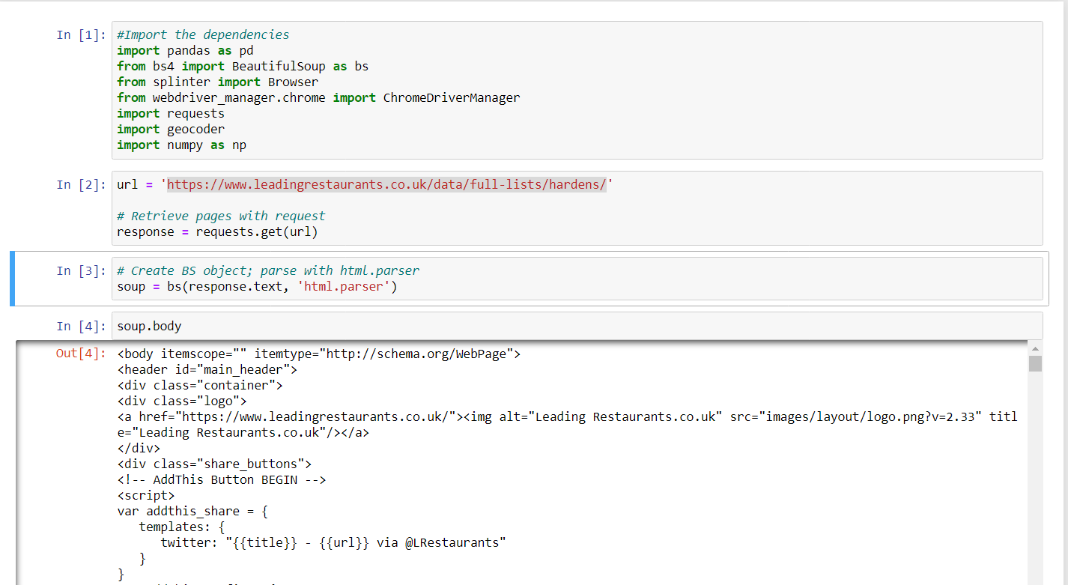

To have a look at the html file in a pretty format

And extract the title

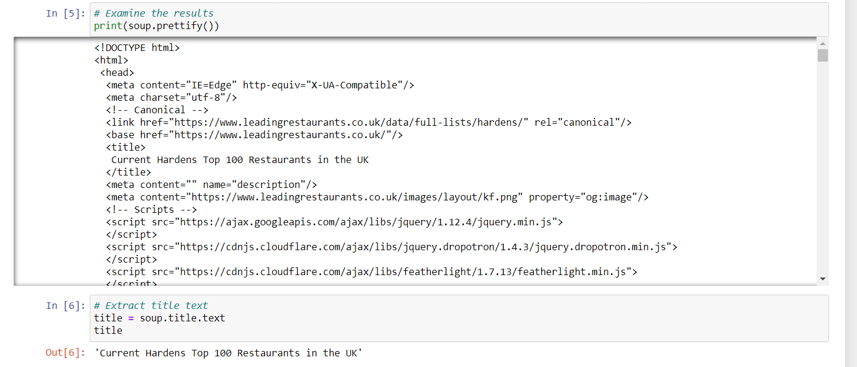

Create columns from the data scraped 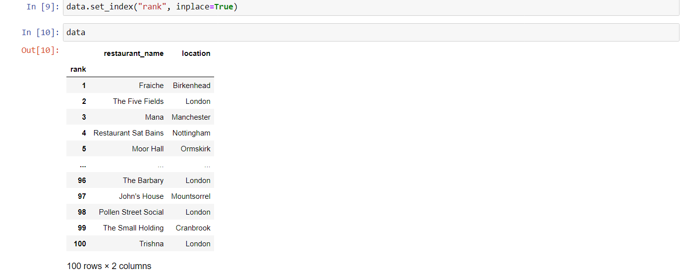

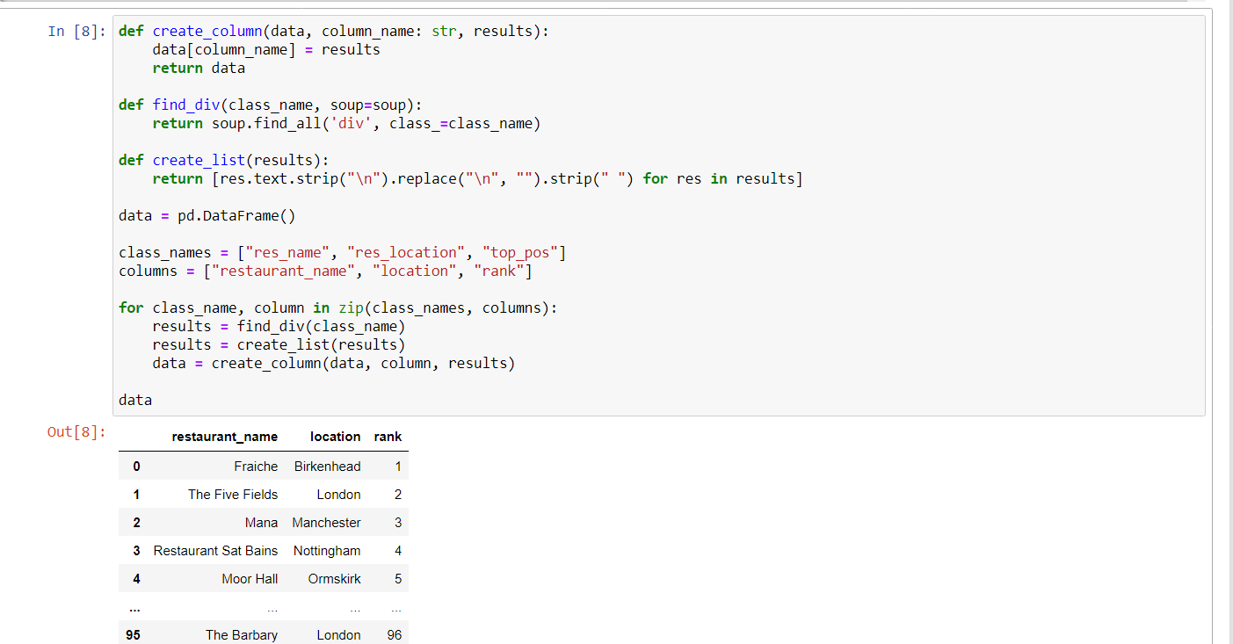

Reset index

Get the links of the restaurant

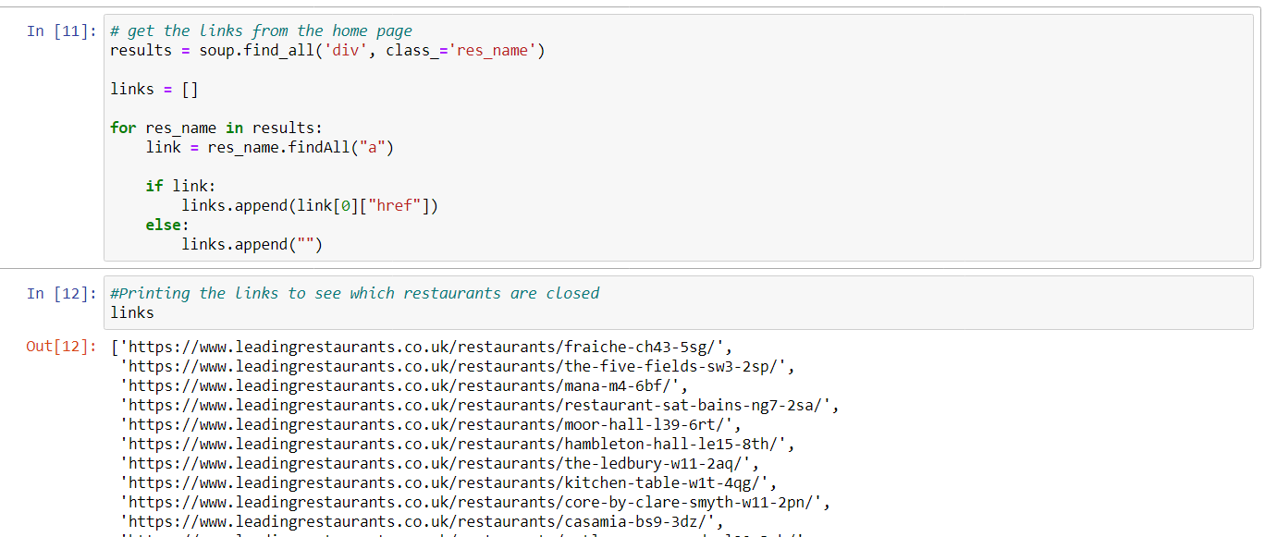

Getting the address from the html in text

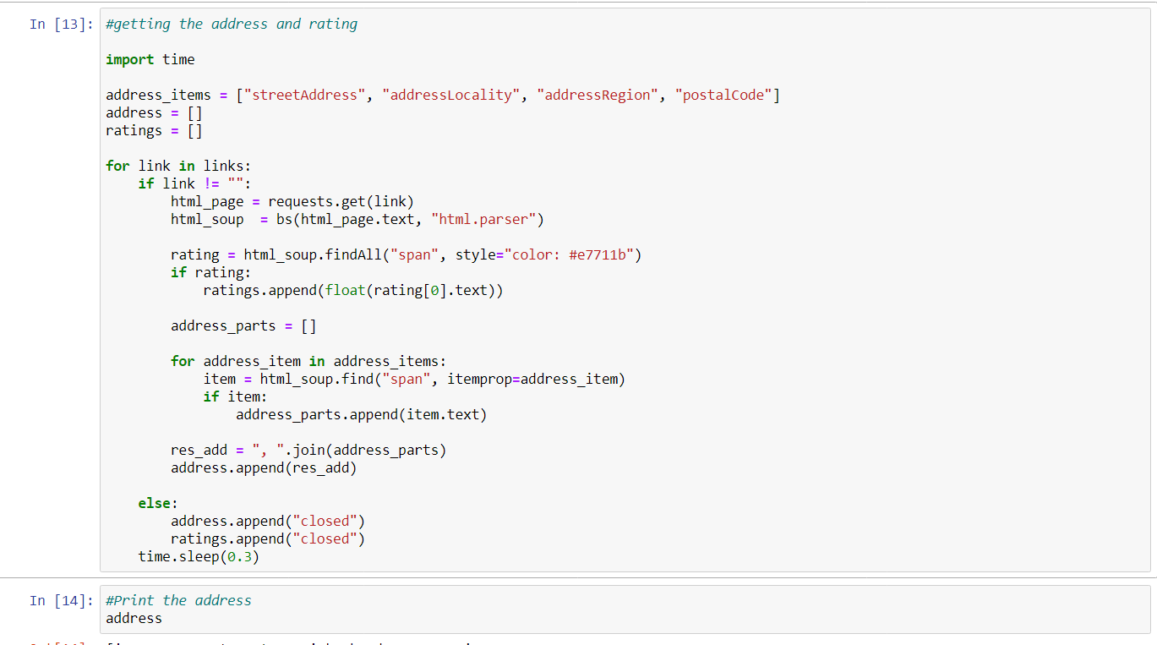

Getting the rating from the html

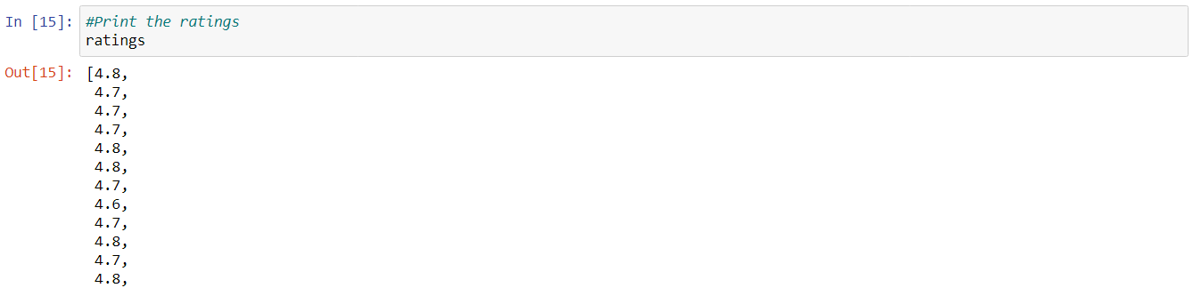

Adding the address and ratings to the dataframe

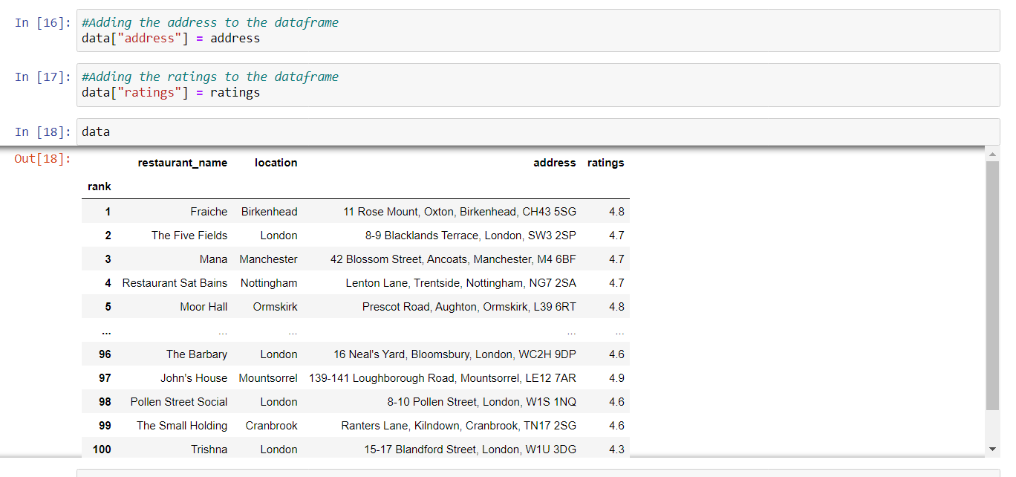

Adding the latitude,longitude and the links to the dataframe

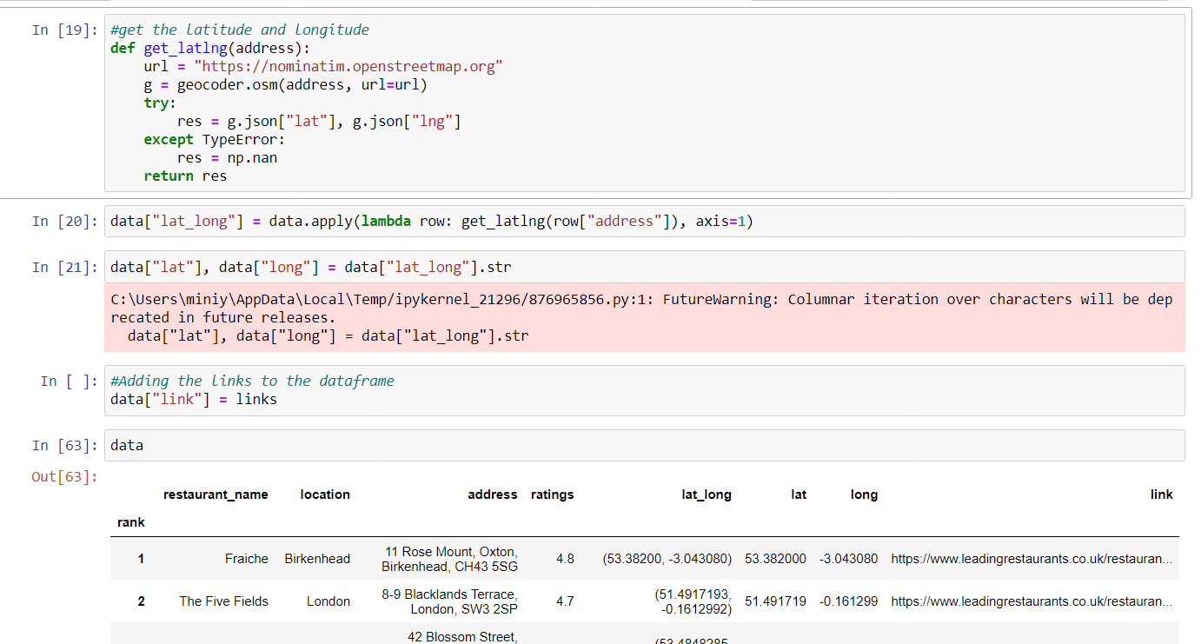

Saving the data to a CSV file

